**How it Works**

1. **Download zip file from the google drive.**
2. **Unzip the CodeRep Project.**
3. **Open the CodeRepository solution.**
4. **Right click on the solution and select “set startup projects”**

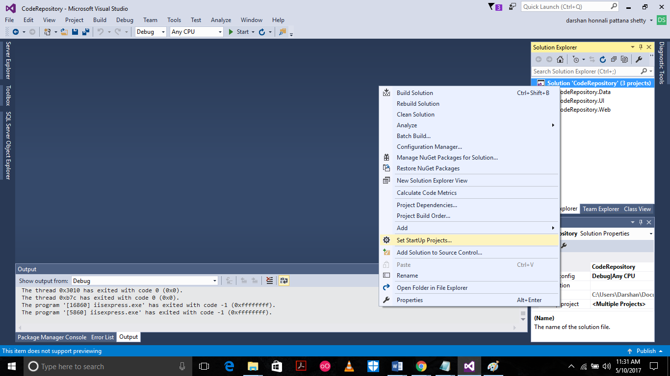

1. **Select “Multiple startup projects”. Set Start for “CodeRepository.UI” and “CodeRepository.Web”**
2. **Run the Application.(A database by the name** CodeRepositoryConnectionNew

**Is created.)**

**Page 1**

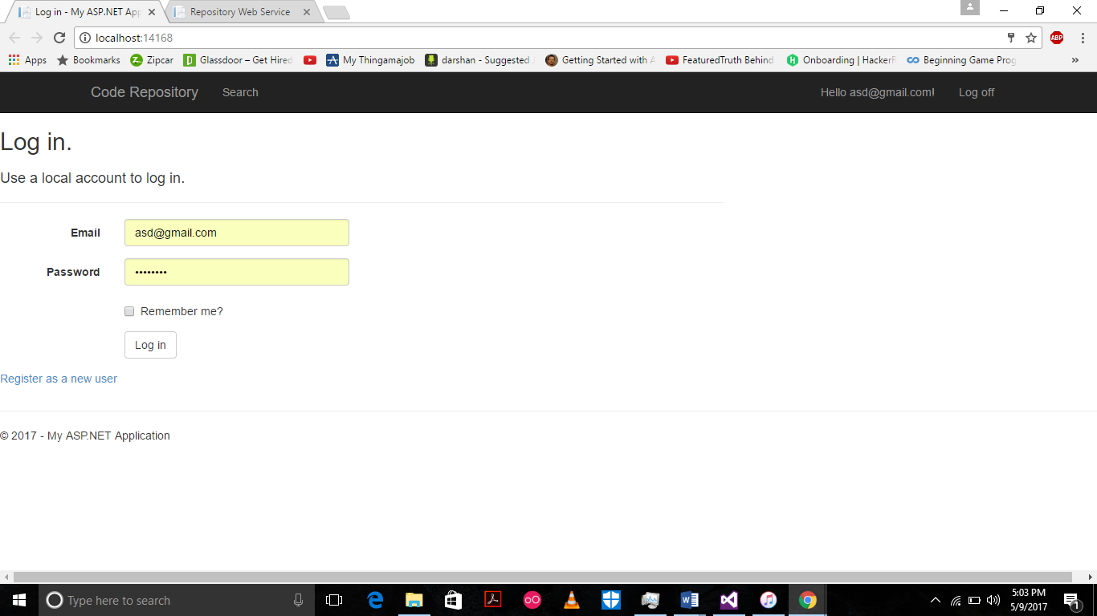

Figure 1

1.      The user registers with his email and a password. His email will be used as his user id.

2.      If he is a registered user he logs in with username and password.

3.      In the next page you see the projects that he has uploaded.

Let’s have the user as [asd@gmail.com](mailto:asd@gmail.com) with password Asd@1234 for the demo.

Register 2 users as [asd@gmail.com](mailto:asd@gmail.com) with password Asd@1234 and [abc@gmail.com](mailto:abc@gmail.com) with password Abc@1234.

**Page 2**

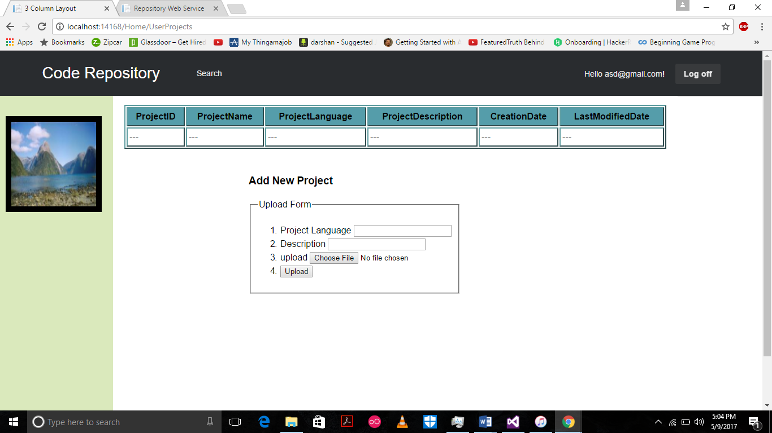

Figure 2

User Projects.

1. Once the user has signed he is navigated to this page where he can see the projects he has uploaded and is working on.
2. There is a table which displays the project details. Like ProjectName,ProjectLanguage,ProjectDescription,CreationDate,LastMOdifiedDate.
3. There is a Upload Form which is used by the user to upload projects. He cana enter project language and description along with it as shown in Figure 3.

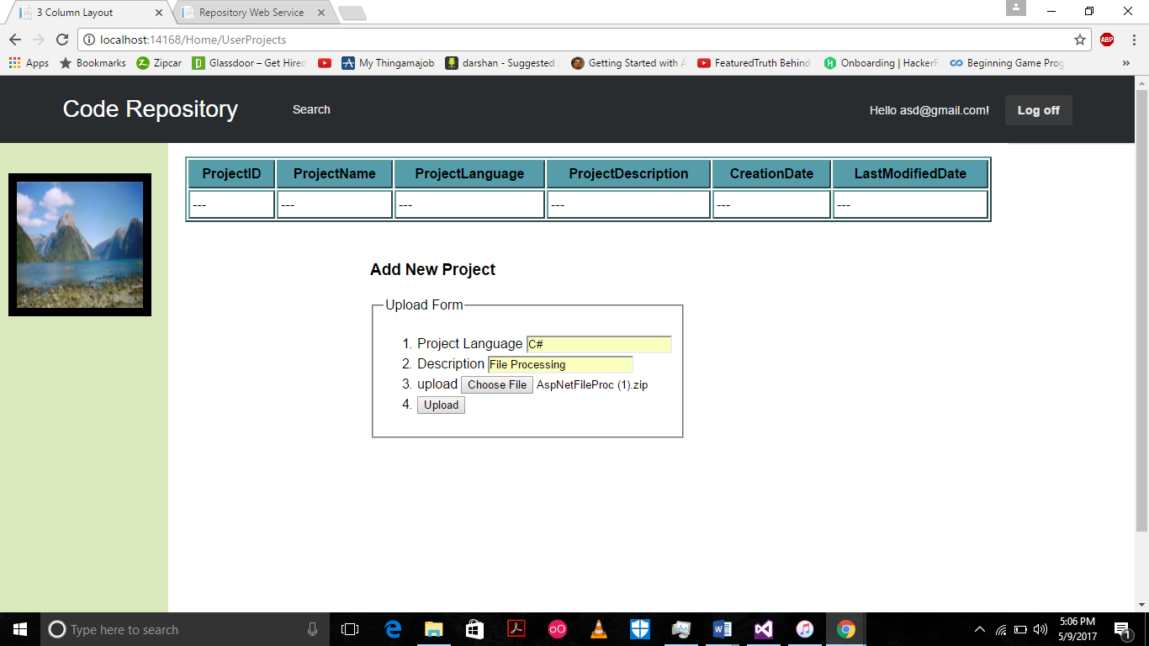

Figure 3

1. Once the user hits upload the project is stored in the DB .
2. The project is also stored on the server(Your PC) in the CodeRep Folder with user email as the folder name.(Example: C:\Users\Darshan\Documents\Visual Studio 2015\Projects\CodeRep\ + “useremail”)

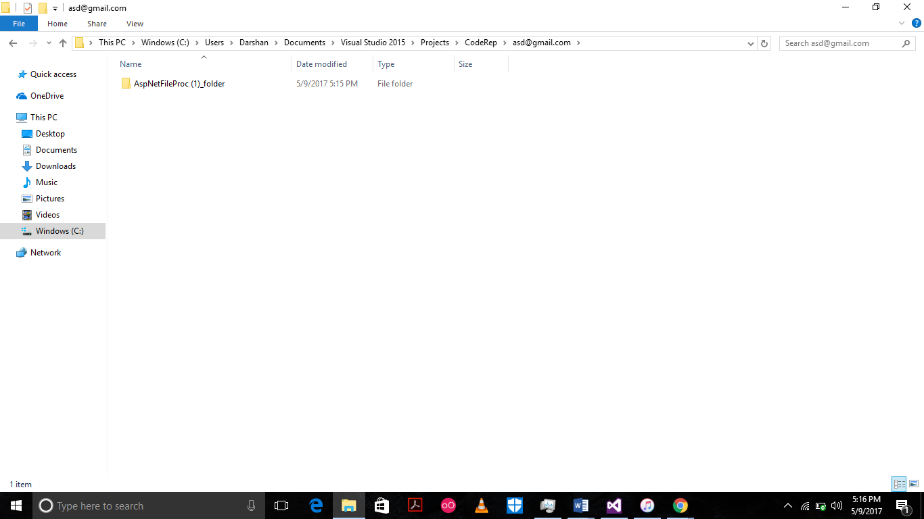

1. Once uploaded the project shows up in the table as shown below

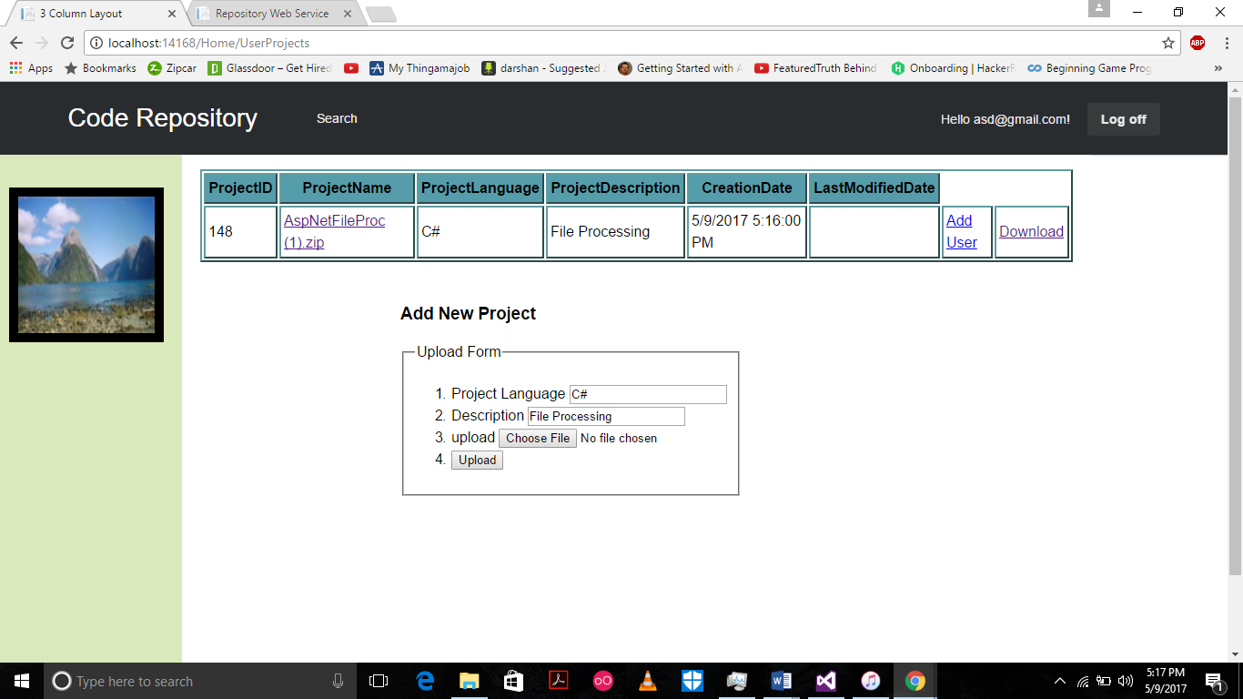

1. You can upload any number of projects as you want.

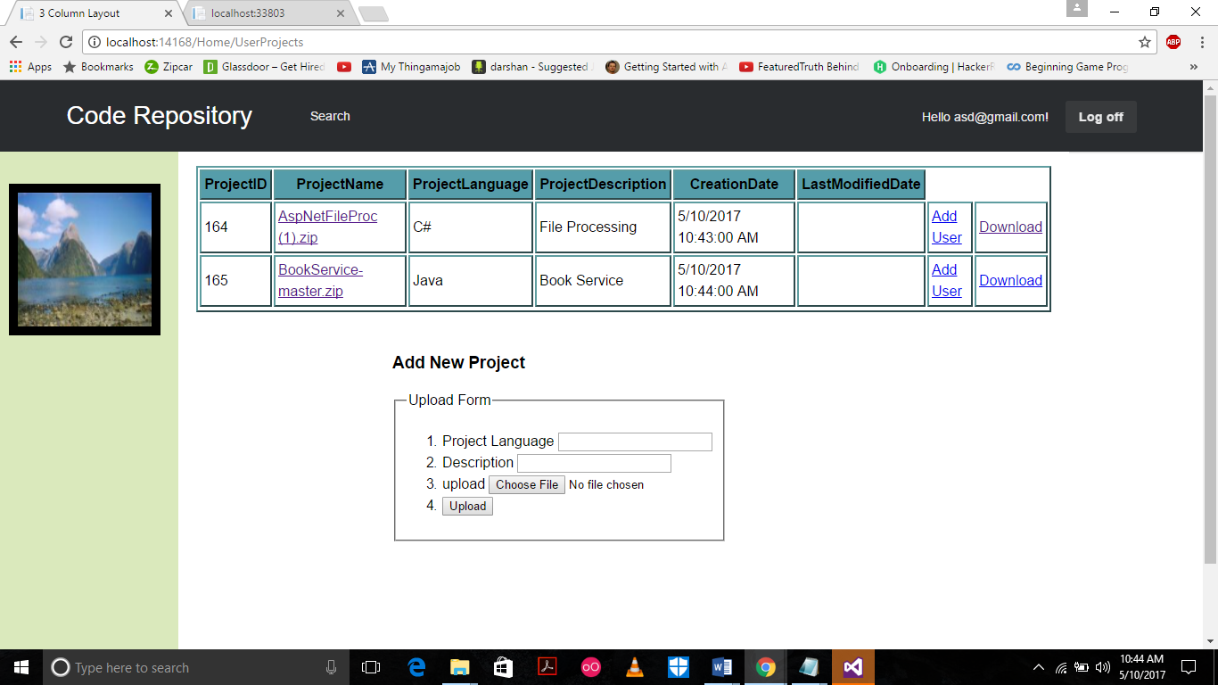

1. Each project row has a add user button which is used to add coAuthors to the project it is explained below.

**Page 3 Multiple User for One Project.**

Lets talk more about this. This is to allow user to add CoAuthors to the project. This means that more than one user can access the same project and make changes to it and also check in the changes.

1. The User clicks on add user. It takes him to a new page with a form to add new user.

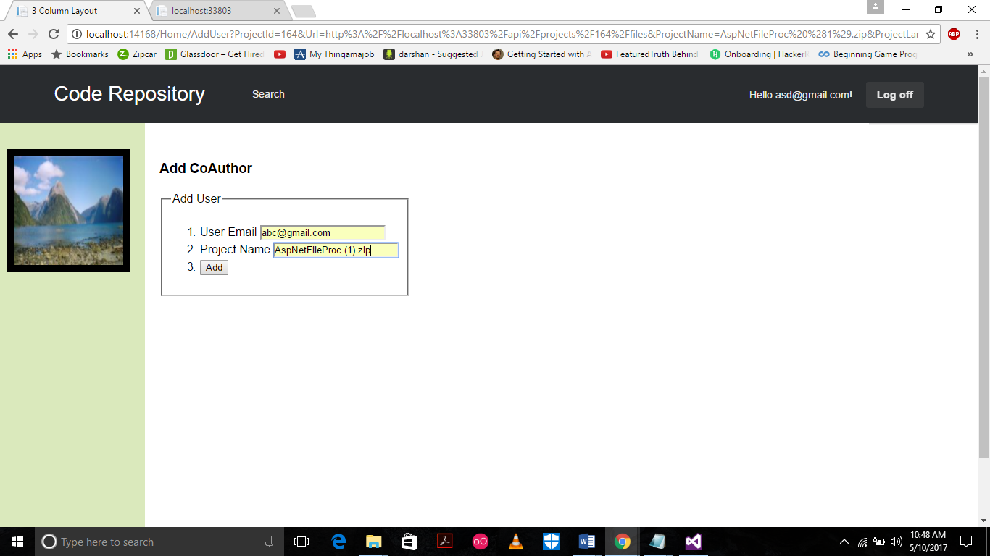

1. Now when the user is added it means that he can acces the same project from the same same folder on the server and also can make changes to the files and check in the changes to the DB.

The CoAuthor is added to the CoAuthor table and also a new project row is added with the same project and new userid.

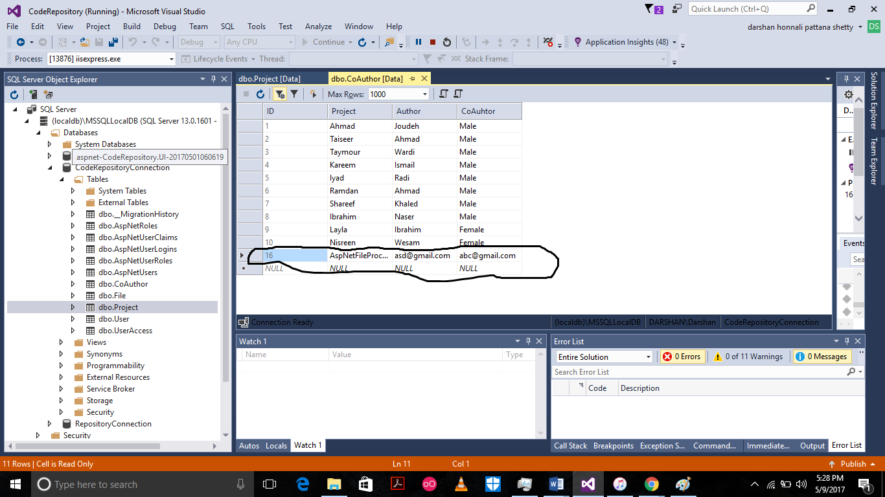

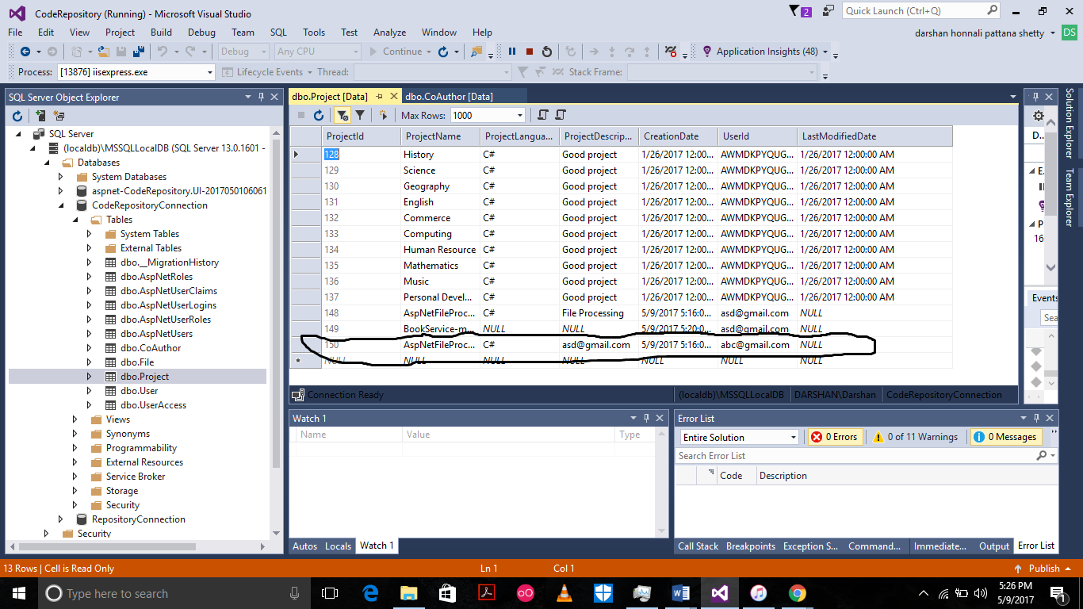

1. Now [abc@gmail.com](mailto:abc@gmail.com) is the CoAuthor to AspNetFileProc (1).zip Project. We will get back to this again to show what [abc@gmail.com](mailto:abc@gmail.com) user can do.

**Page 4**

Project Details- (a.k.a Folder Explorer)

1.      The user once he is on the UserProjects page where all his projects are listed clicks on the name of the Project he wants to look at.

Lets keep AspNetFileProc (1).zip as the project for this demo.

2.      All the files inside the project are shown to the user exactly the same way the user sees it on his PC, like a Windows Explorer.

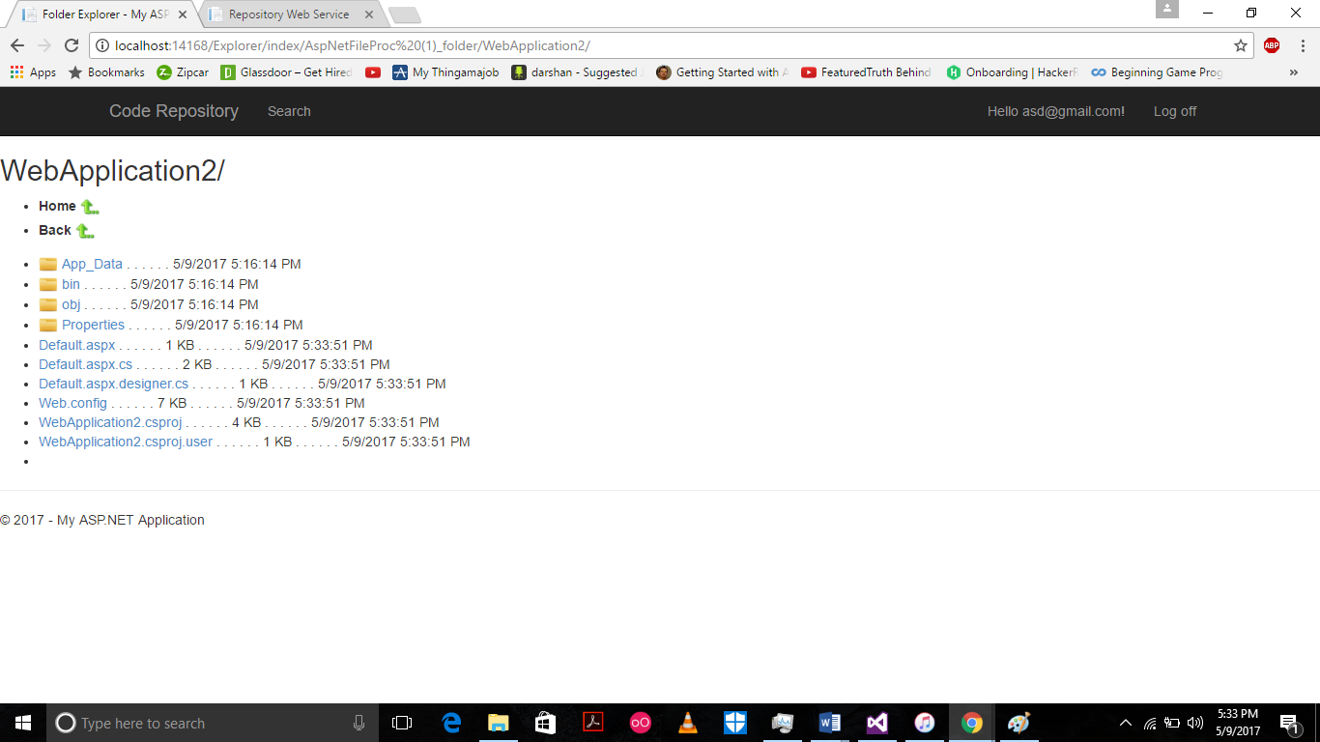

3.      He can click on folders to open and see the folders and files in them and navigate through the project.

4. The **“Back”** button takes you to the parent folder and the **“Home”** takes you back to the **“UserProjects”** page.

5.      When a user clicks on a file in the folder explorer, a new window opens showing the contents of the file.

**Page 5**

**File Details.**

1. When the user clicks on a file in folder explorer a new window opens showing the contents of the file.
2. In this window the file following details are shown

            File Content

* + FileName
  + Project it belongs to.
  + Last Checked in Date
  + Email of user who last  checked in.
  + Version of the file.
  + Show previous version
  + Show next version.

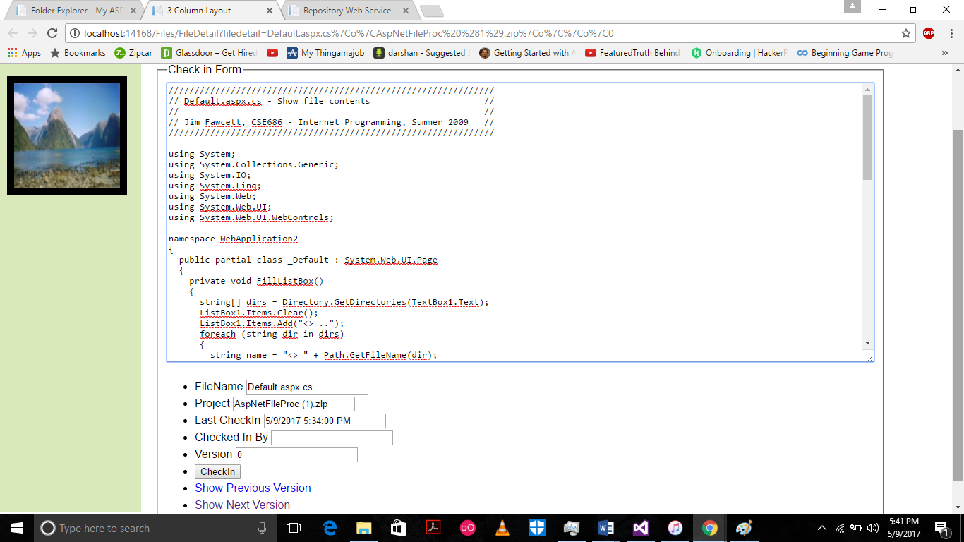

1. Now the user can make the changes he wants to make to the code

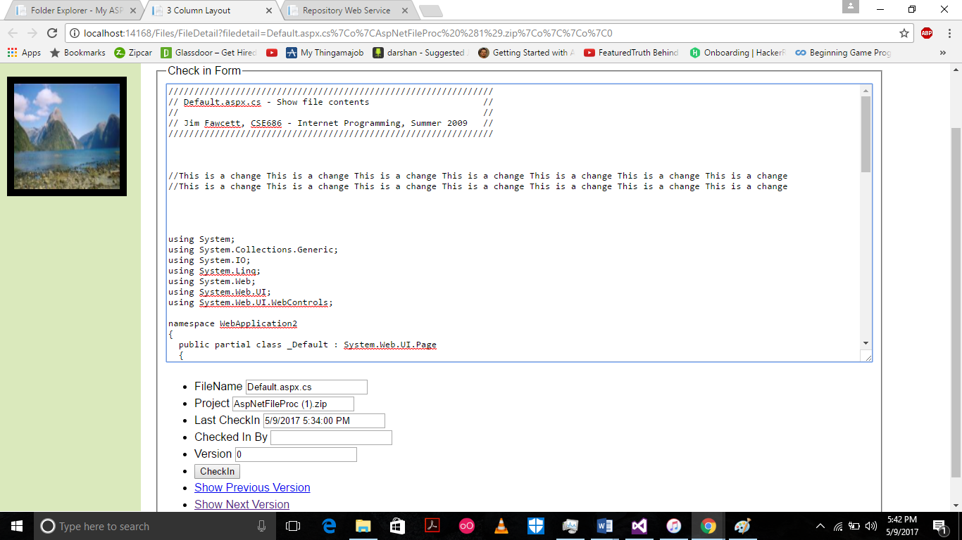

1. After the change is made he can **checkin** the code and the file is checked in along with the user email as the **checked in user**.
2. It also records the **CheckInDate.**
3. Once the file is checked in the **version** of the file is increased by 1.

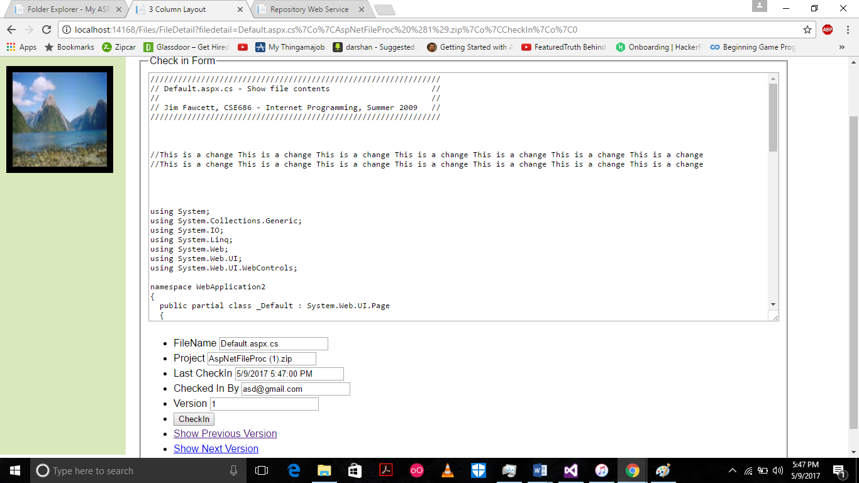

1. How check in works.

* Once the user checks in the new version of the file is stored in DB along with the file content and all its details.
* A new folder is created inside the project folder by the name **“Version_”+Version Number+”_Files”**
* Now the next time any one opens the same file the newest version of the file is shown.
* As and when the file gets checked in the file is saved in the corresponding version folders depending on the version of the file.

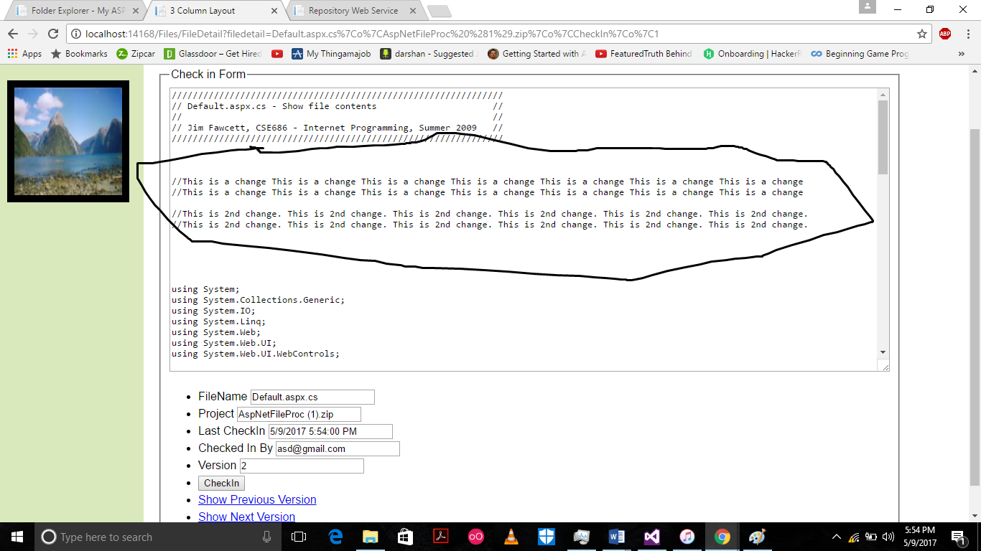

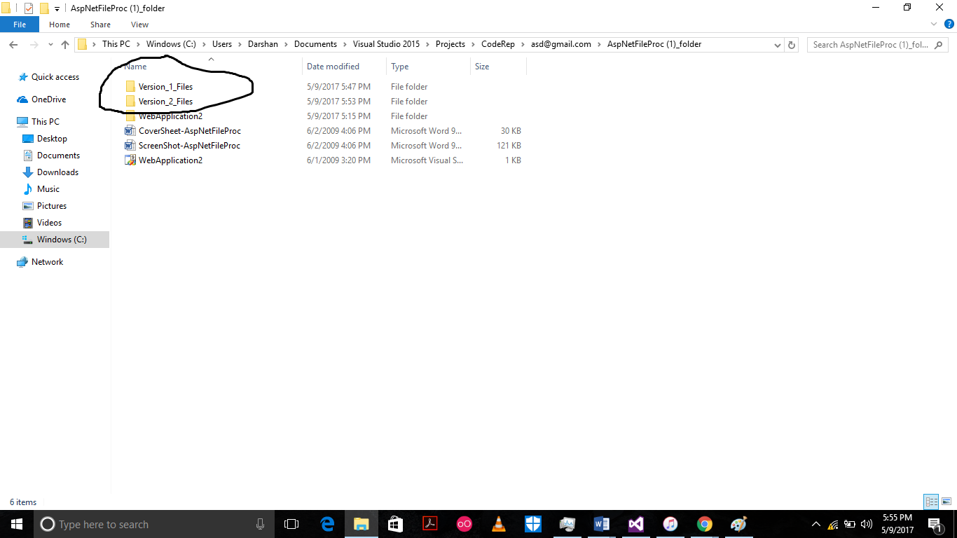

**Important Note** - Now when the CoAuthors to this project login and click on the file they will see the latest version of the file too..

1. So Basically a **history of the changes** is maintained.
2. Now when the user clicks on the **“Show Previous Version”** button the previous verion of the file is hsown and if he thinks that is what works better with the code than the latest version he can check that in and that will be the latest version for the project and the changes will be reflected for all the CoAuthors as well.
3. When the user clicks on the **“Show Next Version”** button the next version to the present version is shown.

**Page 6 - Download**

1. In the User Projects page each row has a **“Download”** button along with it.
2. When the user clicks on the button the entire project along with all the different version folders is **zipped and downloaded**.

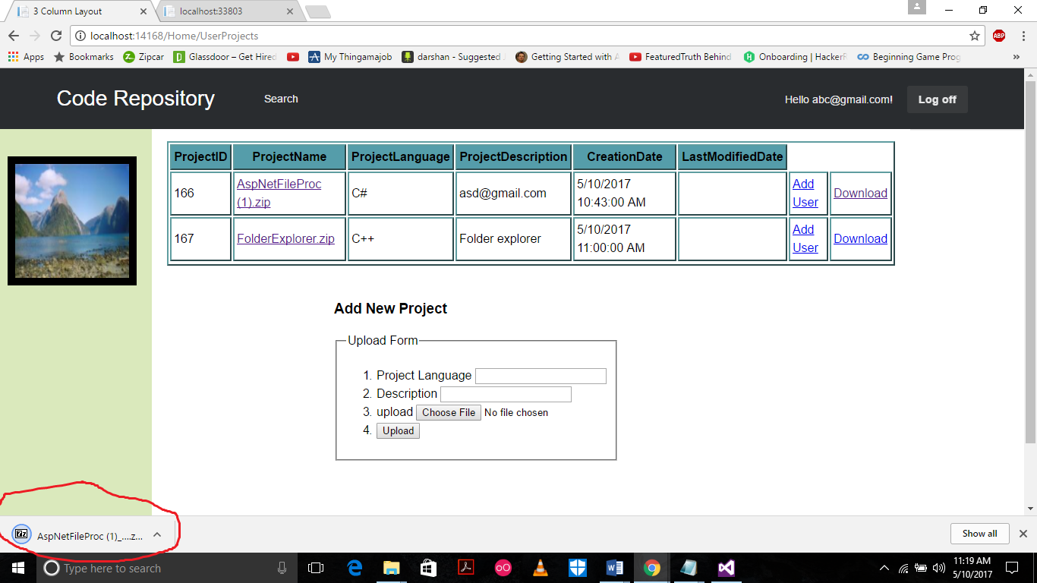

**Page 7 – Search**

1. There is a **Search** button in the **header of each page**.
2. This is used to search the projects uploaded by all users in Code Repository.
3. When the user clicks on **Search** new page opens with a search form.
4. The user has to **only enter the first few letters** of the Project name and all the projects starting with that name and also all the CoAuthors working on them is brought up.
5. One can easily see who are working together on a project as in cases of CoAuthors working on project the Main Auhtor is also shown.

For this let us login as a new user [abc@gmail.com](mailto:abc@gmail.com) with password Abc@1234

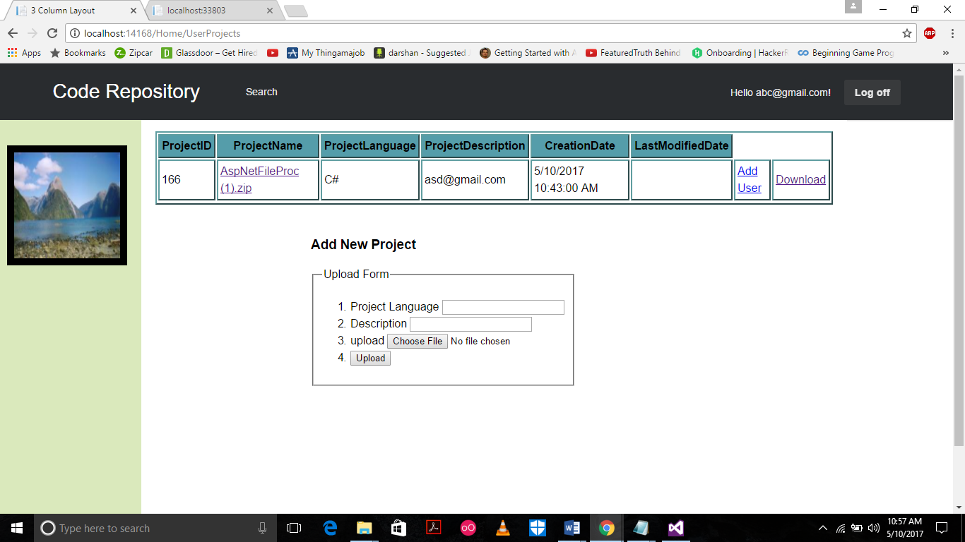

We can see he has access to **AspNetFileProc(1).zip** as he was added as he **CoAuthor** by [abc@gmail.com](mailto:abc@gmail.com).

Now he can navigate through the **AspNetFileProc(1).zip**  and make changes he wants.

He can also add his own projects.

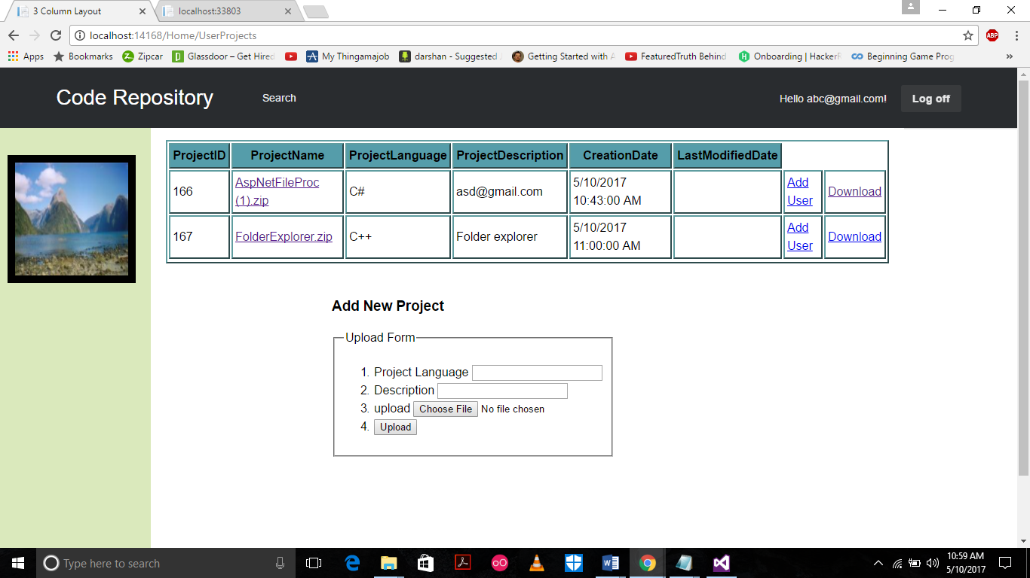

Now when he clicks the **Search** button the Search Project page opens.

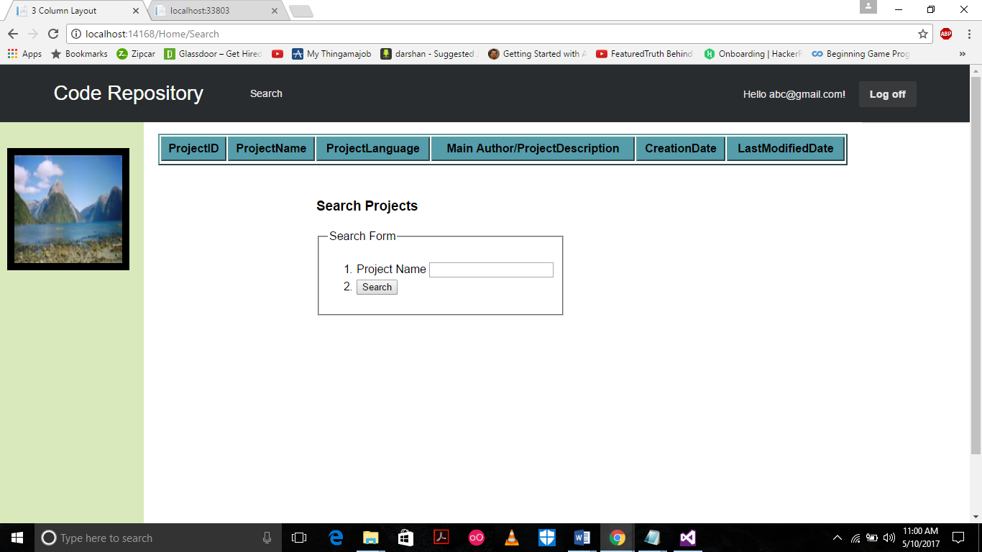

Here he can search for all the projects in the Code repository.

Let us search BookService-master with just the first two letters bo.

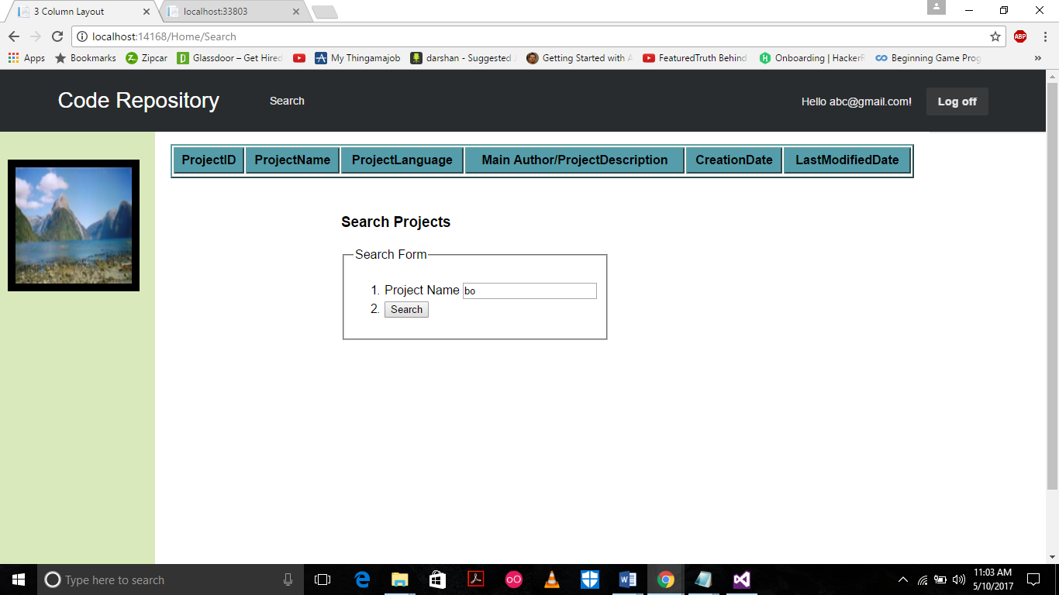

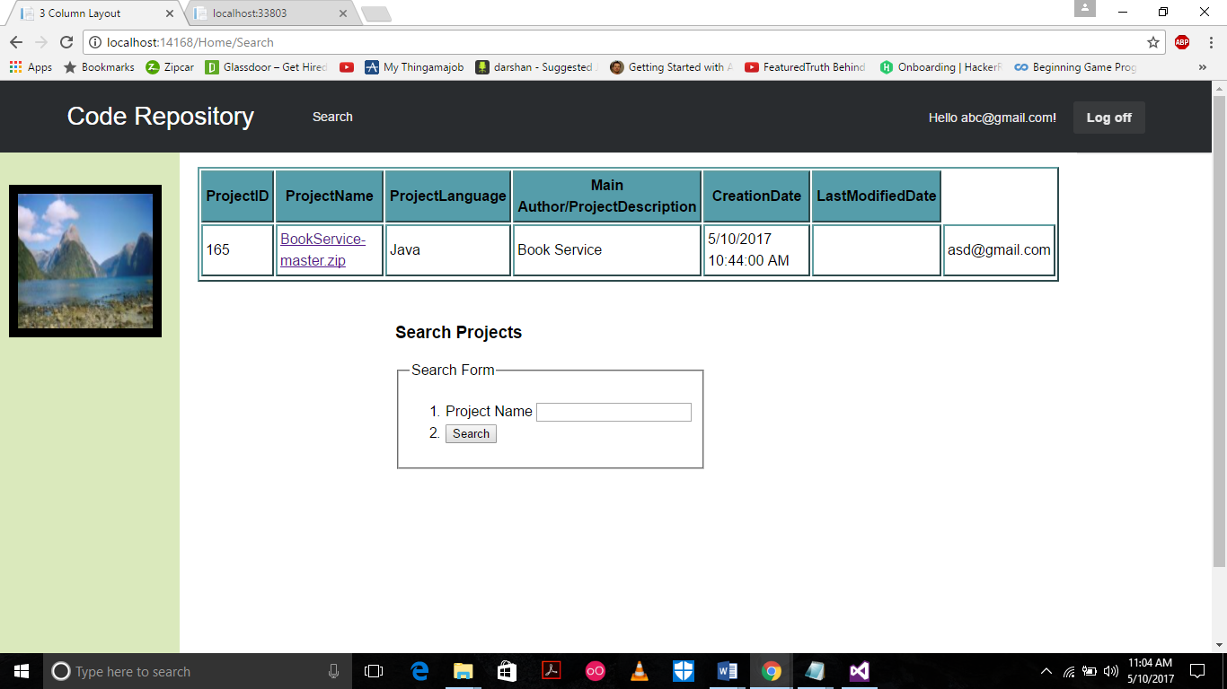

Now you notice that the Author for this project is [asd@gmail.com](mailto:asd@gmail.com) and [abc@gmail.com](mailto:abc@gmail.com) is not a CoAuthor. But still he can naviate through the project, look at the files and folders in the project.

**But most importantly he cannot make any changes and checkin. So the project is secure.**

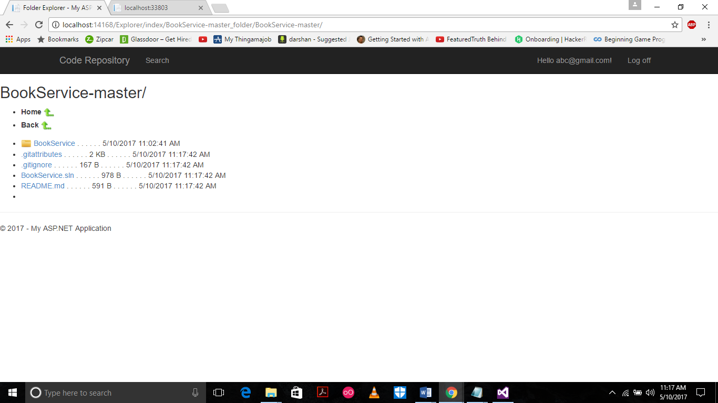

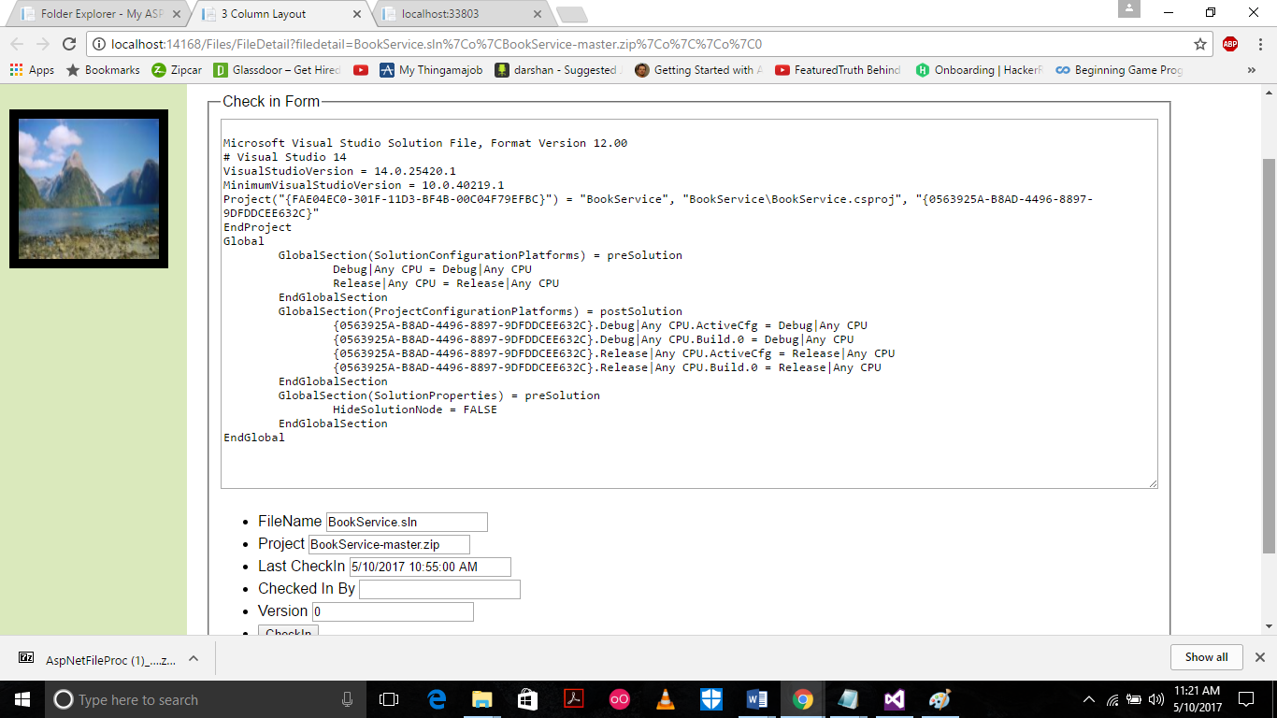

**Page 8 - Web Service.**

**When you hit start on the project it launches two pages one is for the Code repository and the other is for the WebAPi.**

Put **“/Repository.asmx”** along with the localhost.

A new page opens with all the methods of the web service.

I have implemented 3.

